

Arab American University

Faculty of Engineering and Information Technology

Assembly lab

Prepared by:Suha Waleed Alardah

ID:201811033

To:Dr.Tareq Zanoon

To:Mrs.NOOR

Task1: Allow the user to enter 3 digit number and convert to binary

dosseg

.model small

.data

num equ 10

.code

main:

mov ax,@data

mov ds,ax

mov dl,num

mov ah,1

int 21h

sub al,30h

mul dl

mov bx,ax

mov ah,1

int 21h

sub al,30h

add al,bl

mul dl

mov bx,ax

mov ah,1

int 21h

sub al,30h

add bl,al

mov ah,4ch

int 21h

end main

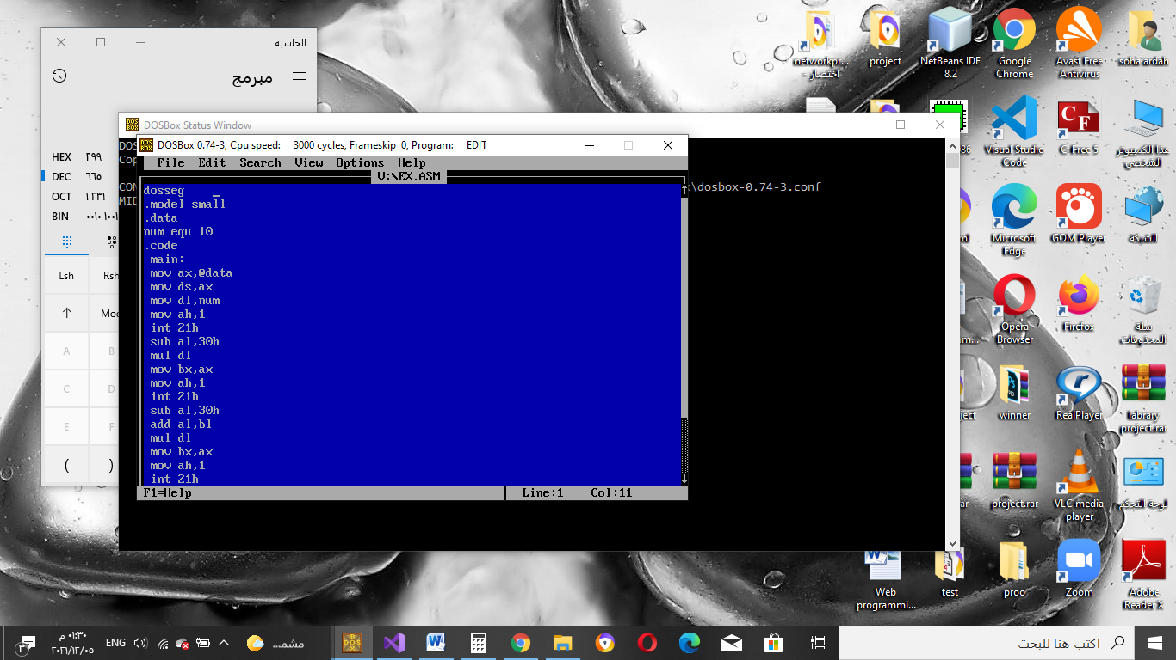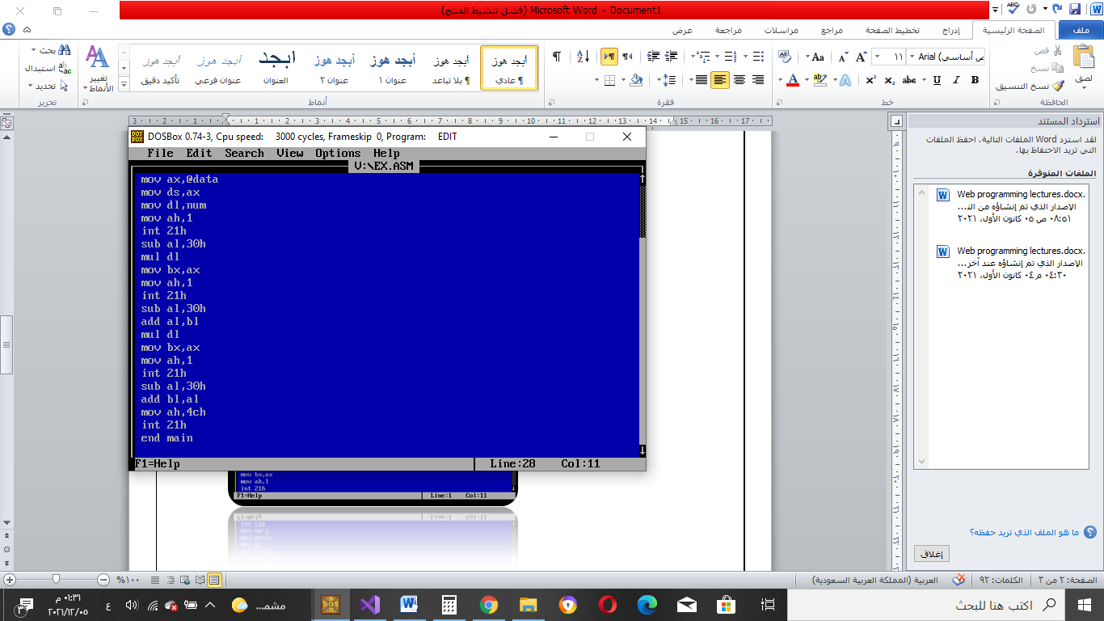

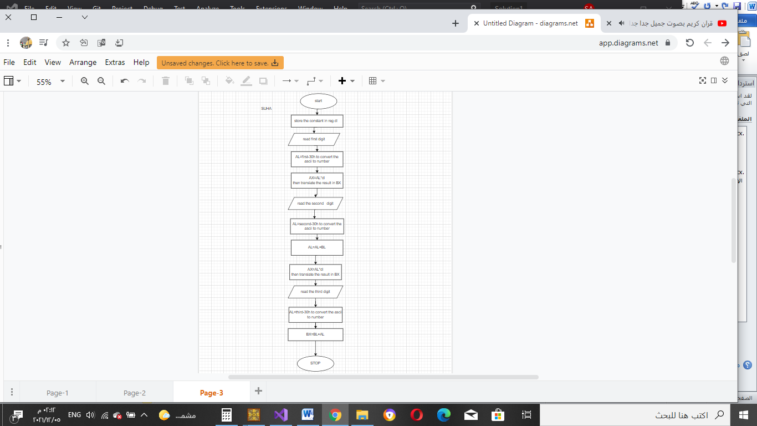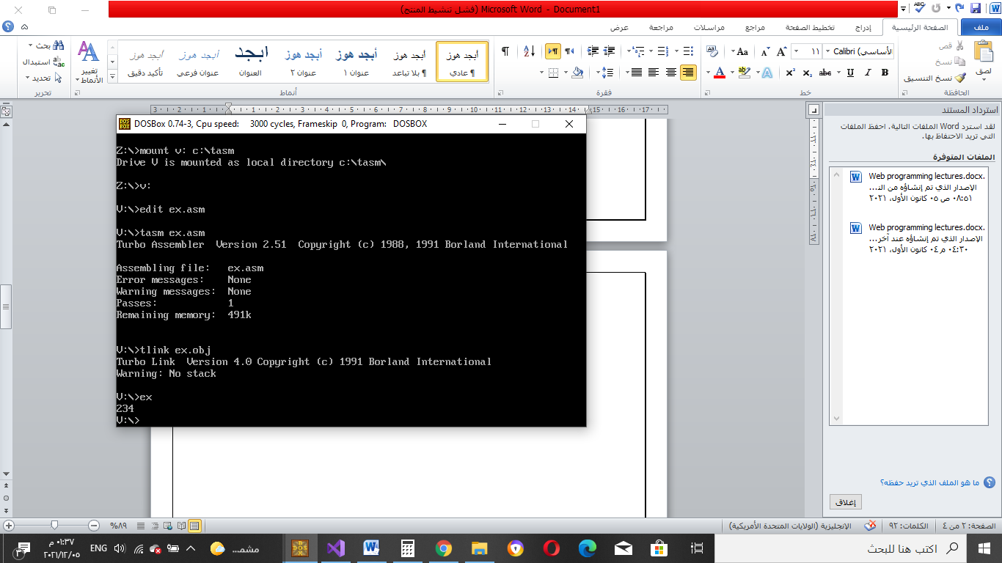

Task2:Using TD check if the binary value matches the entered number

EXAMPLE :IF WE ENTER 889 THE BX WILL DISPLAY 379 BECOUSE THE NUM.CONVERT FROM DEC TO HEX

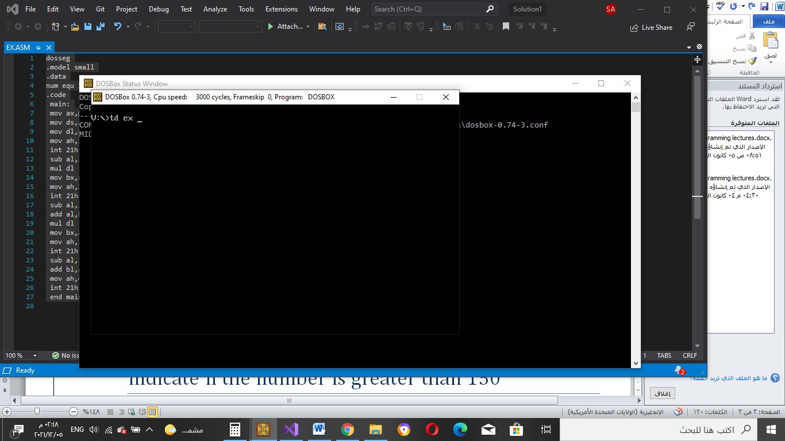

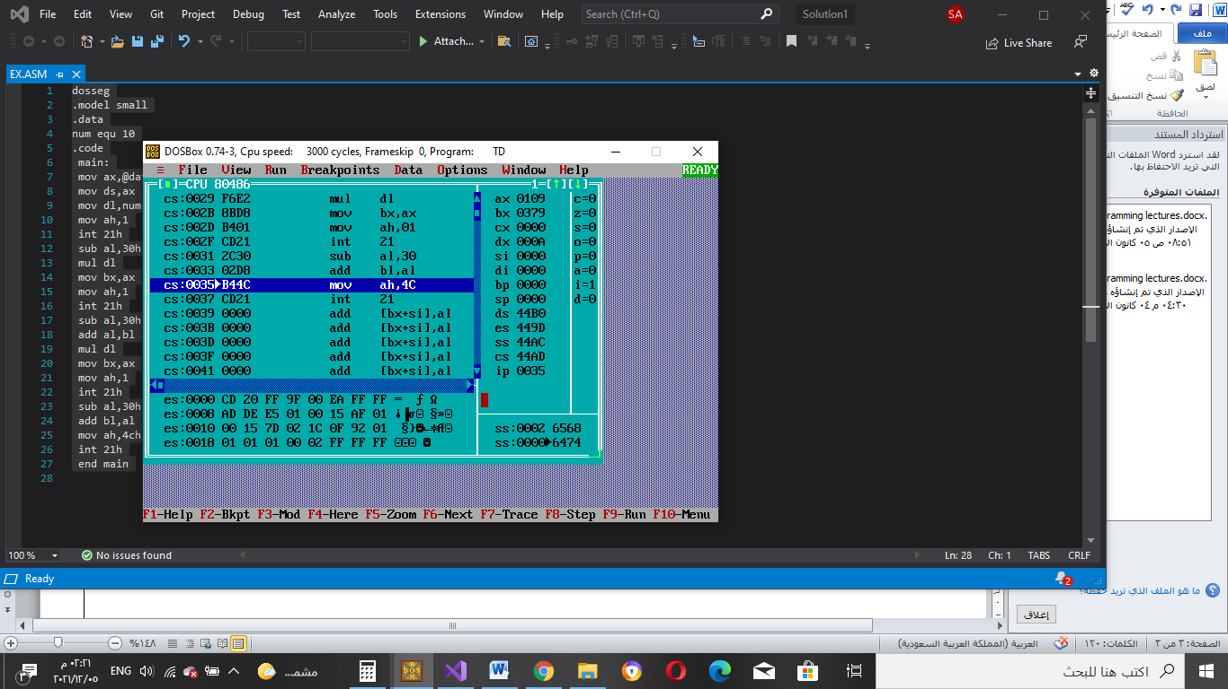

Task3:

indicate if the number is greater than 150

